QUESTION # 1

DIFFICULTY: EASY

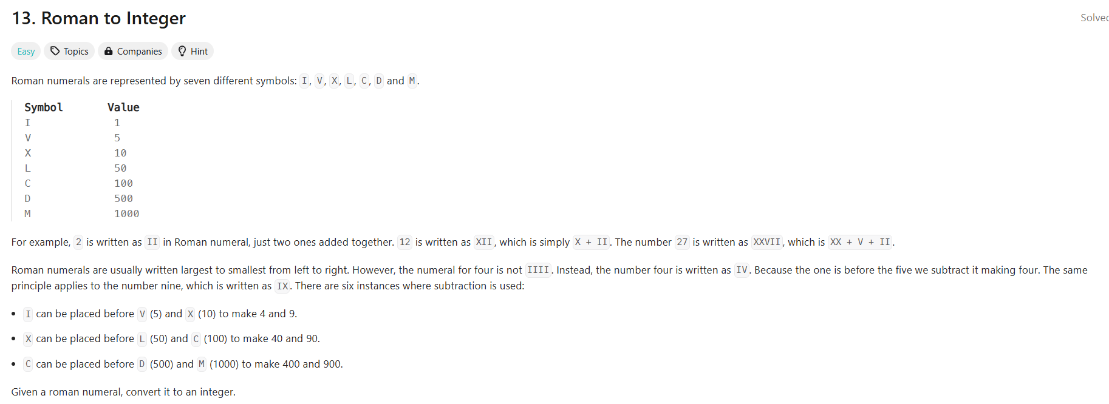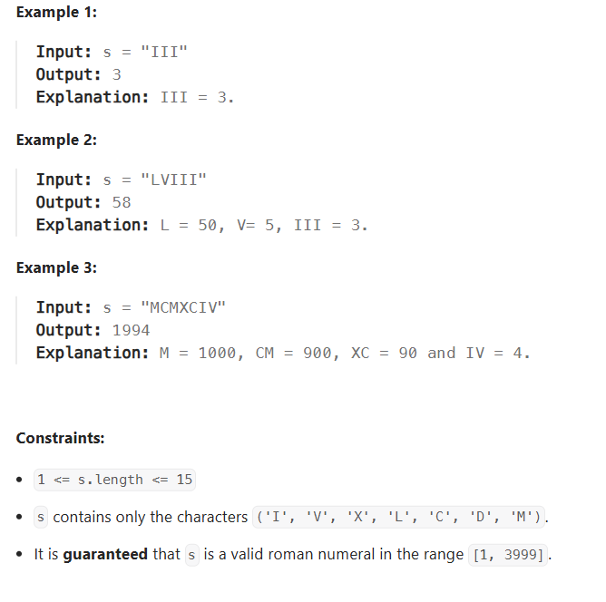
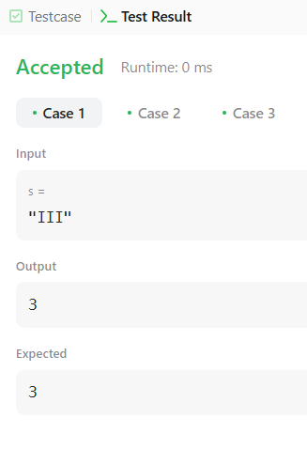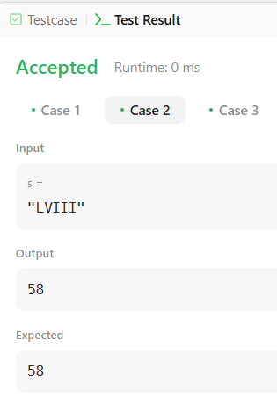

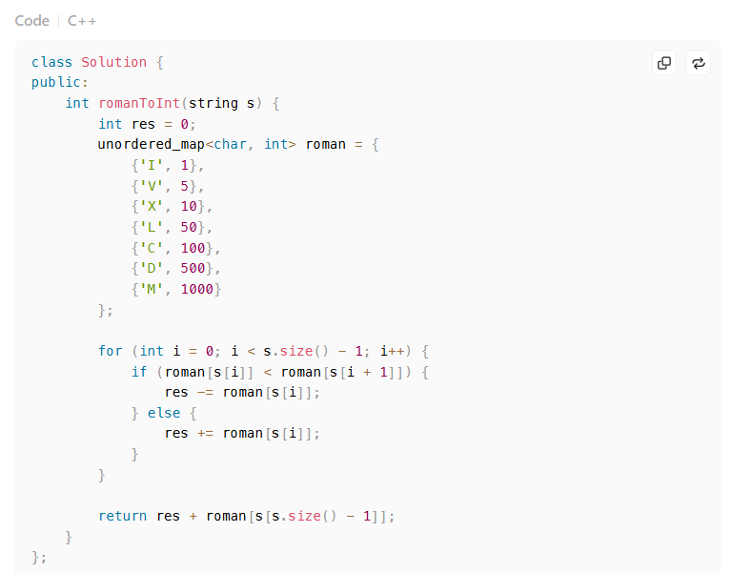

Description + My Approach (C++):
I created a map to store the values of Roman characters. Then, I looped through the string up to the second last character. At each step, I checked if the current Roman numeral was smaller than the next one. If yes, I subtracted its value (for cases like IV, IX). Otherwise, I added it. Finally, I added the value of the last character outside the loop. This logic helped me convert the Roman numeral into an integer in one pass.

QUESTION # 2

DIFFICULTY: EASY
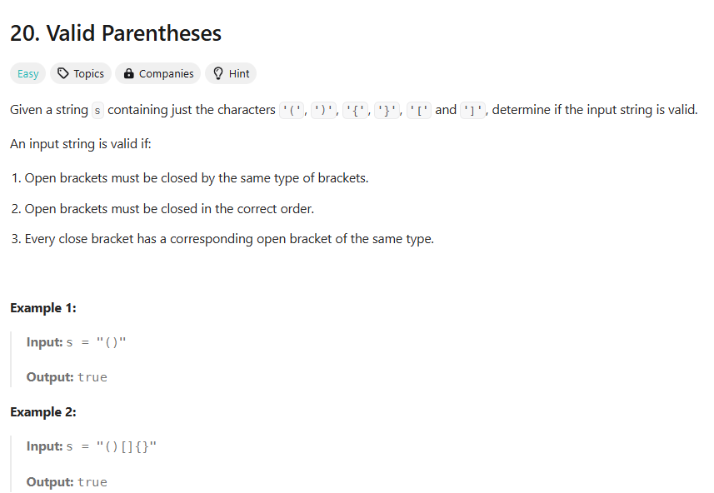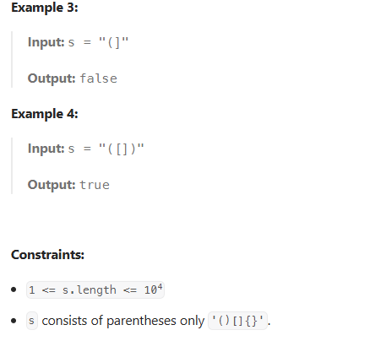
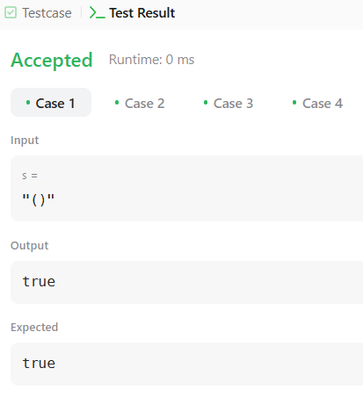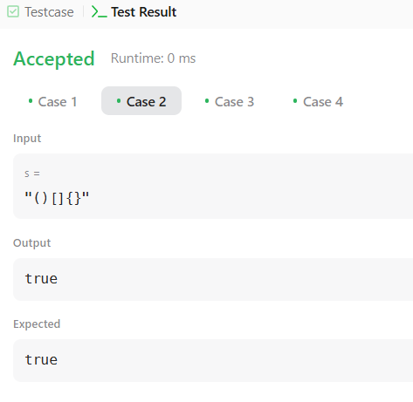

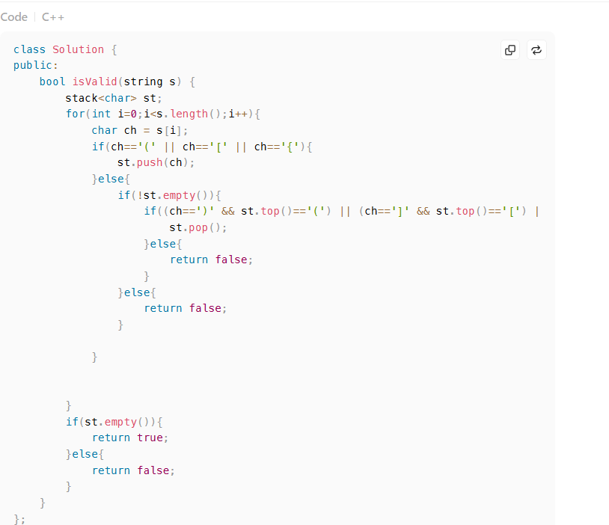

Description + My Approach (C++):
I used a stack to keep track of the opening brackets. As I went through each character in the string, I pushed the opening brackets onto the stack. When I found a closing bracket, I checked if the stack wasn’t empty and if the top matched the correct opening bracket. If it did, I popped it; otherwise, I returned false immediately. After the loop, if the stack was empty, it meant all brackets were properly closed, so I returned true Otherwise, I returned false.

QUESTION # 3

DIFFICULTY: EASY

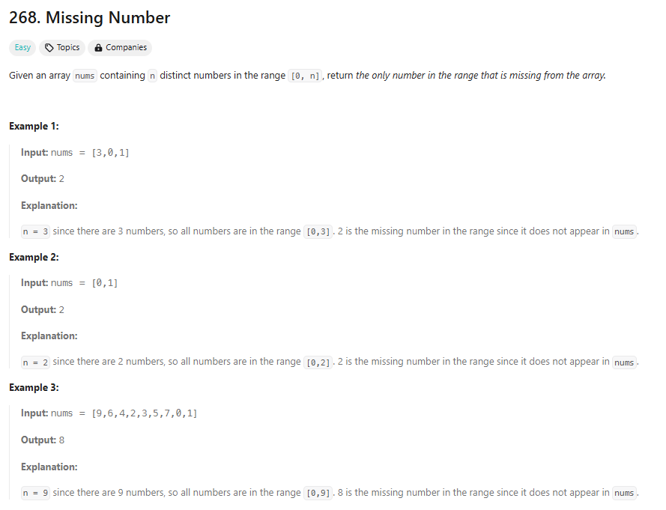
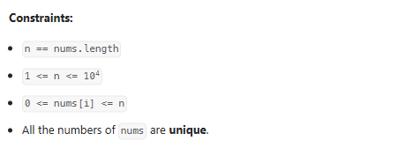
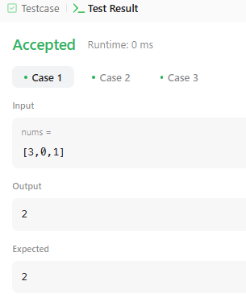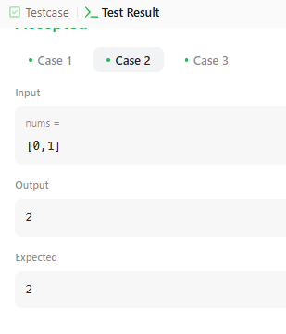
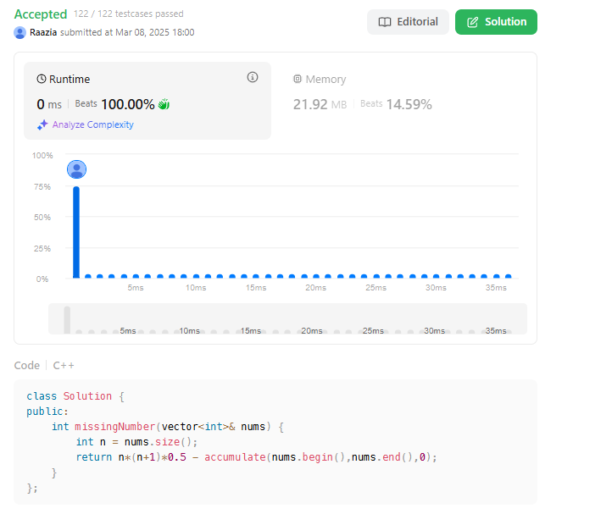

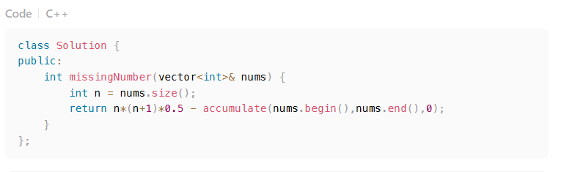

Description + My Approach (C++):
I used the formula for the sum of the first n natural numbers: n * (n + 1) / 2. This gives me the expected total sum if no number was missing. Then, I used accumulate to get the actual sum of the numbers in the array. By subtracting the actual sum from the expected one, I found the missing number in constant time and space.

QUESTION # 4

DIFFICULTY: MEDIUM

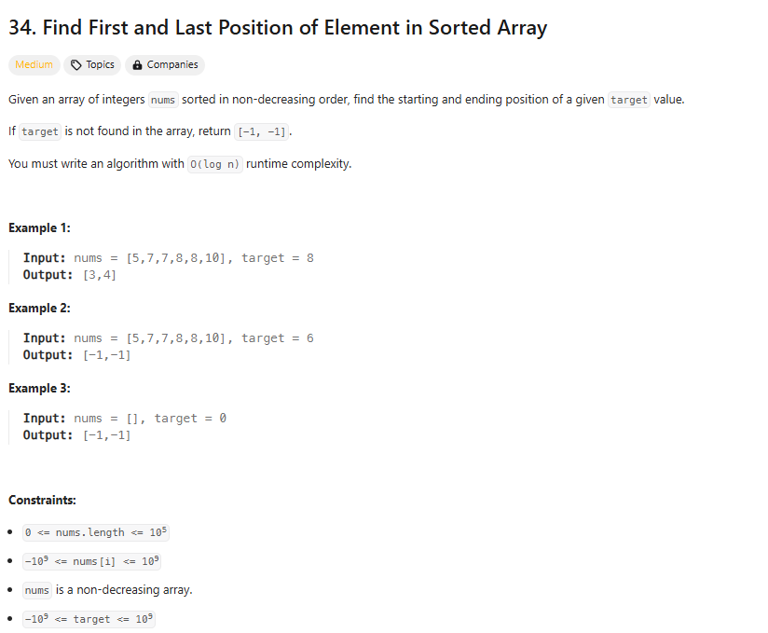

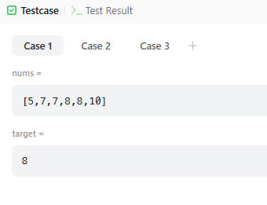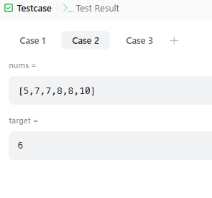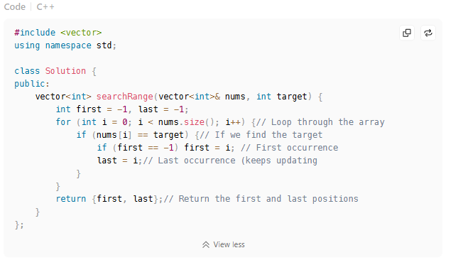

Description + My Approach (C++):
I looped through the array to find the first and last positions of the target. I initialized both to -1. As I went through the array, when I found the target, I set first if it wasn’t already set, and kept updating last each time I found the target again. After the loop, I returned both indices. This approach works correctly but is linear in time, not the most optimal, since I didn’t use binary search.

QUESTION # 5

DIFFICULTY: EASY

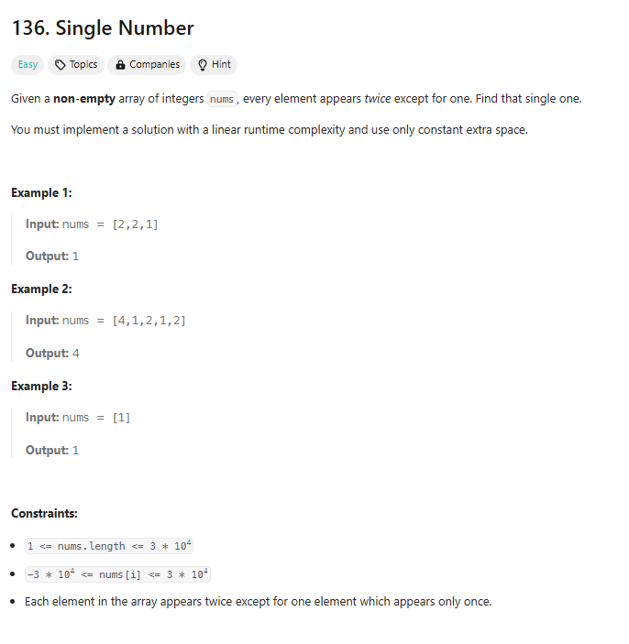
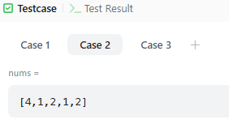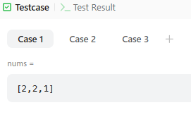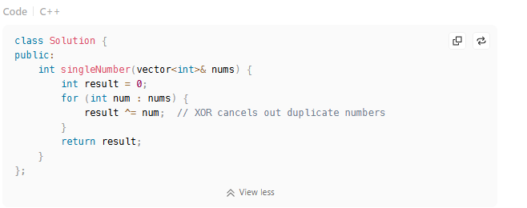

Description + My Approach (C++):
I used the bitwise XOR (^) operator to solve this efficiently. I initialized a variable result to 0, then XORed every number in the array. Since XOR of two same numbers is 0 and XOR with 0 keeps the number unchanged, all duplicate numbers canceled each other out — leaving me with the single number that appears only once. This gave me a clean O(n) time and O(1) space solution.

QUESTION # 6

DIFFICULTY: EASY

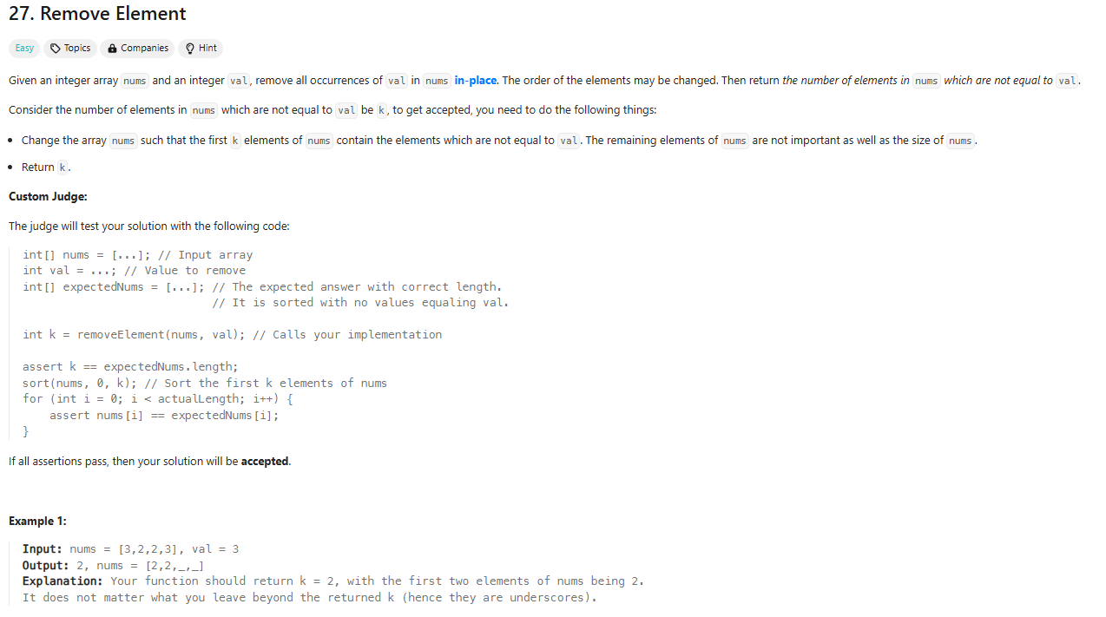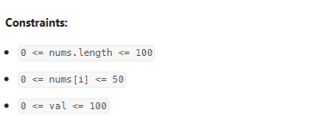
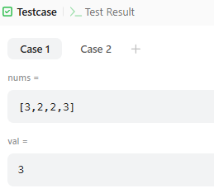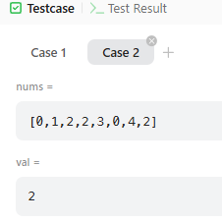

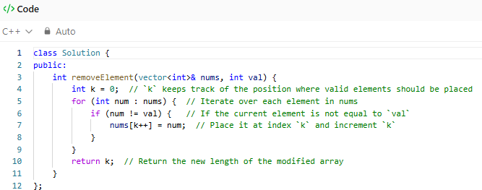

Description + My Approach (C++):
I used a variable k to track where the valid elements (those not equal to val) should be placed in the array. I iterated through the array, and whenever I encountered an element that wasn't equal to val, I placed it at the position k and incremented k. At the end of the loop, k holds the new length of the array with the valid elements, and I returned k as the result.

QUESTION # 7

DIFFICULTY: EASY

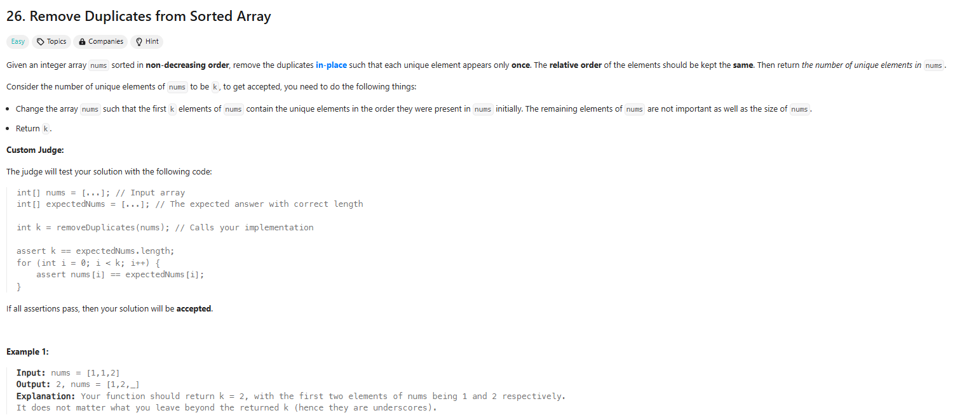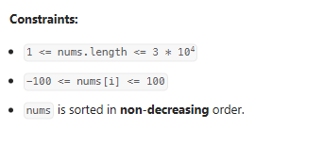
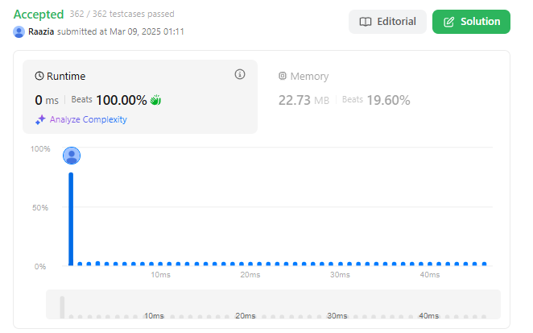
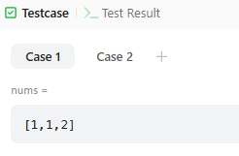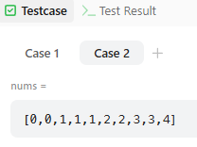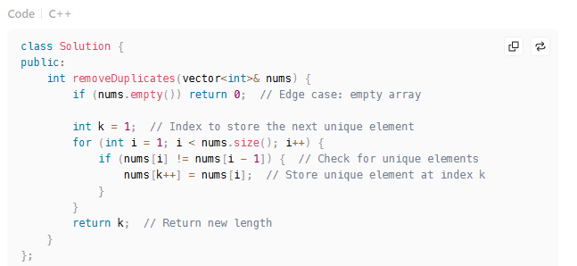

Description + My Approach (C++):
I handled the edge case where the array is empty first. Then, I initialized k to 1, which keeps track of where the next unique element should go. I iterated through the array starting from index 1, checking if each element is different from the previous one. If it was, I placed it at index k and incremented k. Finally, I returned k, which represents the new length of the array with unique elements.

QUESTION # 8

DIFFICULTY: EASY

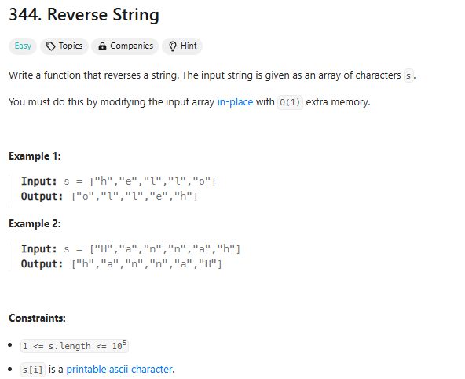
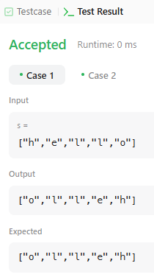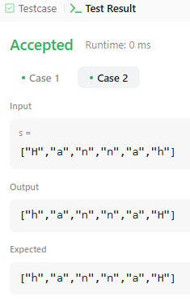

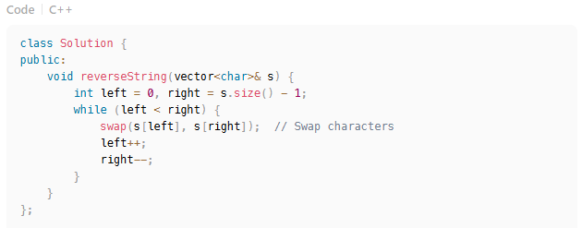

Description + My Approach (C++):
I used a two-pointer approach to reverse the string in-place. I initialized left to 0 and right to the last index of the array. Then, I swapped the characters at left and right, and moved the pointers towards the center: incrementing left and decrementing right. This process continued until left was no longer less than right, effectively reversing the string.

QUESTION # 9

DIFFICULTY: EASY

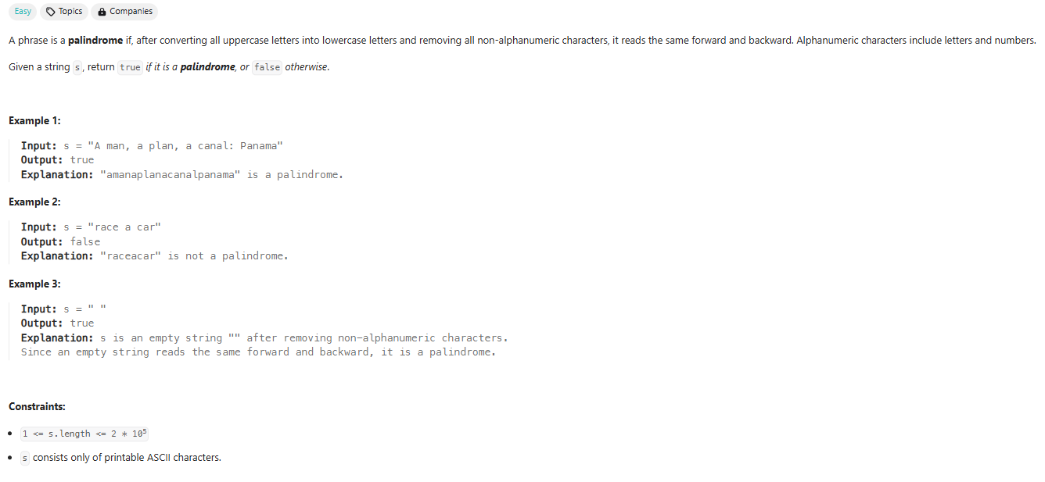


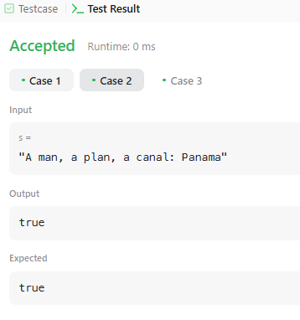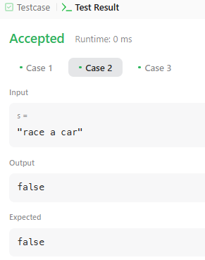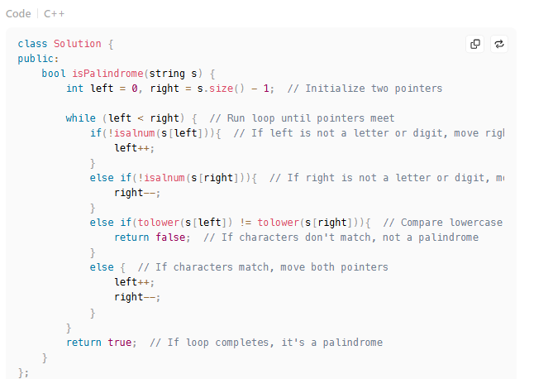

Description + My Approach (C++):
I used a two-pointer technique to check if the string is a palindrome. I initialized left at the start and right at the end. As long as left is less than right, I skipped any non-alphanumeric characters and then compared the lowercase versions of the characters at left and right. If they matched, I moved both pointers inward. If at any point they didn't match, I returned false. If the loop completed successfully, I returned true, confirming it's a palindrome.

QUESTION # 10

DIFFICULTY: EASY
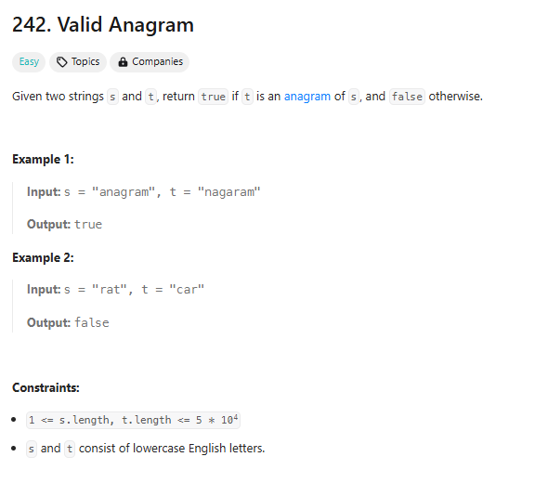

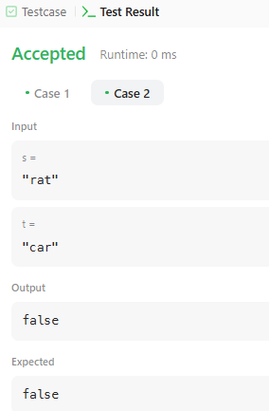
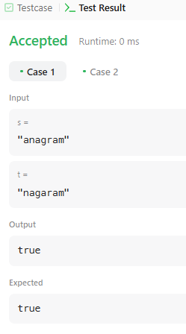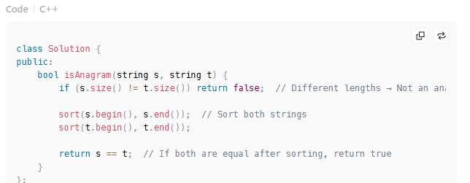

Description + My Approach (C++):
I first checked if the lengths of the two strings s and t were equal — if not, they can't be anagrams, so I returned false. Then, I sorted both strings and compared them. If the sorted versions of both strings are equal, it means the strings contain the same characters in the same frequency, and I returned true. Otherwise, I returned false.

QUESTION # 11

DIFFICULTY: MEDIUM

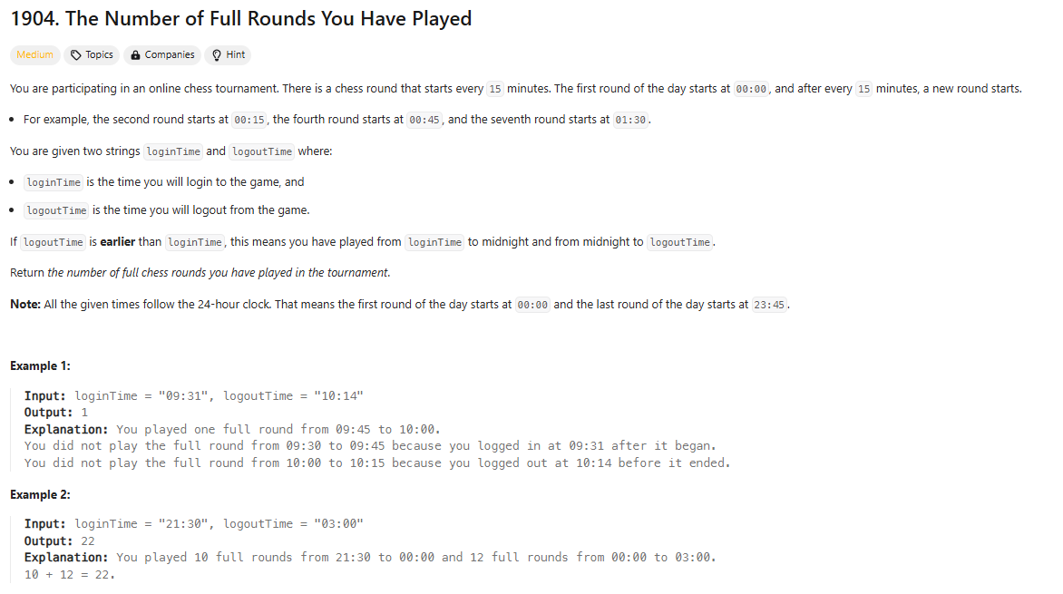
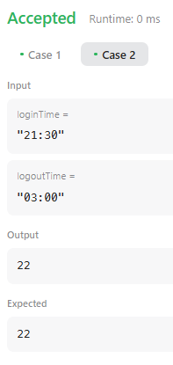
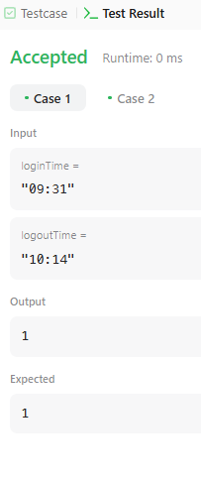


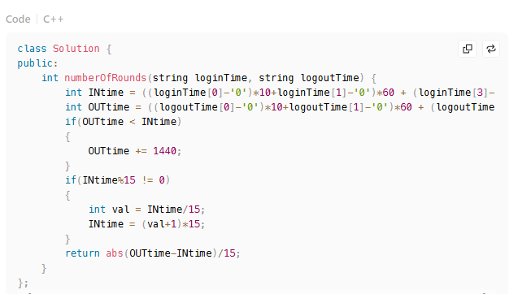

Description + My Approach (C++):
I first converted the loginTime and logoutTime into minutes from midnight by extracting and calculating the hours and minutes separately. Then, I handled the case where the logoutTime is the next day by adding 1440 minutes (24 hours) to it. After that, I ensured the loginTime is rounded up to the nearest 15-minute mark. Finally, I calculated the difference in minutes between the two times and divided it by 15 to find how many 15-minute rounds occurred between login and logout.

QUESTION # 12

DIFFICULTY: MEDIUM

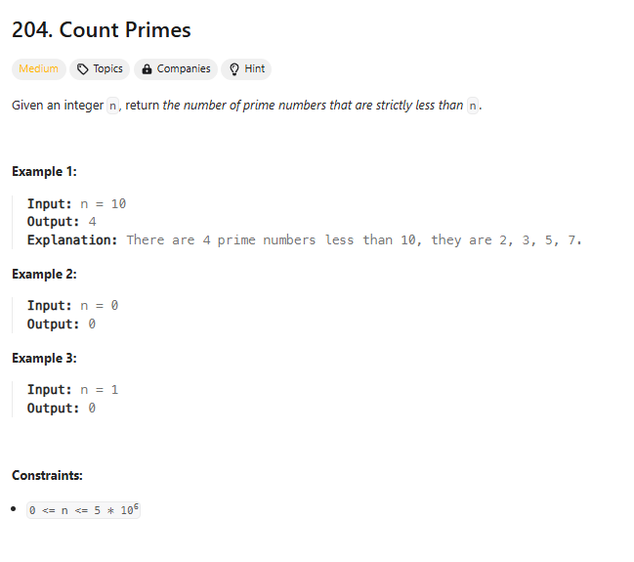
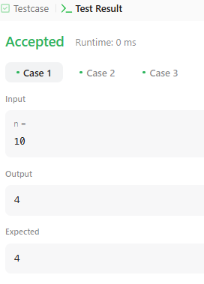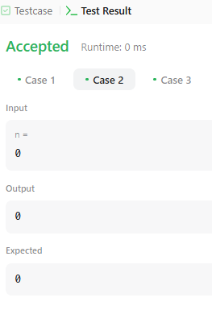

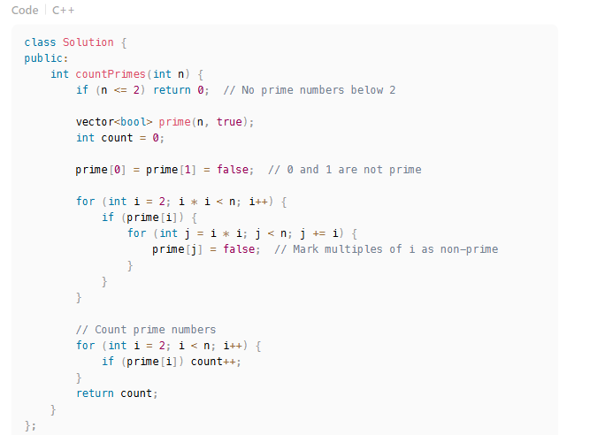

Description + My Approach (C++):
To count the number of primes less than n, I used the Sieve of Eratosthenes method. I started by creating a vector called prime where each index represents whether the number is prime. I set 0 and 1 as non-prime and then iterated through numbers starting from 2. For each prime, I marked all of its multiples as non-prime. After that, I simply counted the numbers that remained marked as prime and returned that count.

QUESTION # 13

DIFFICULTY: EASY

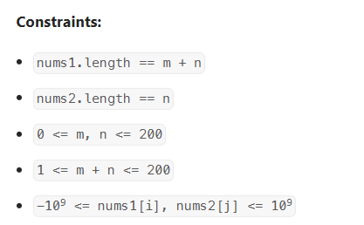
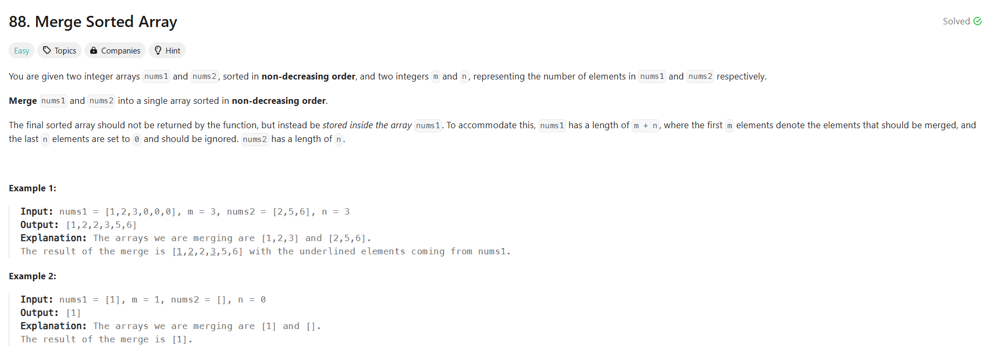

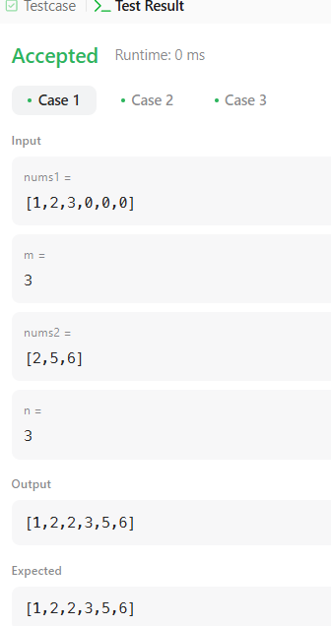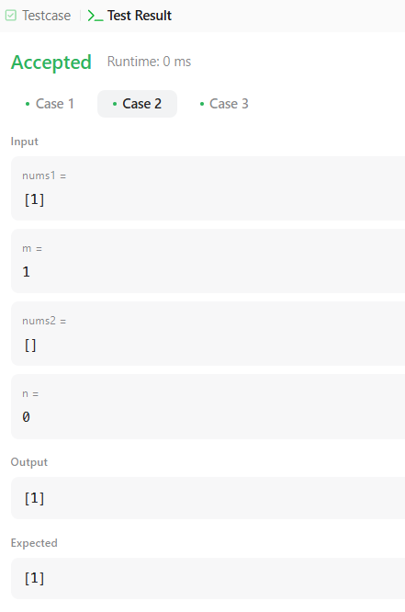


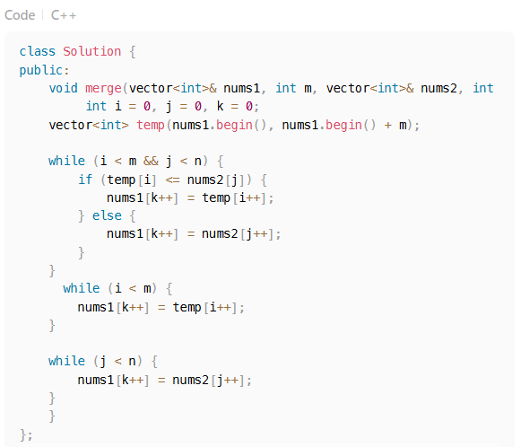

Description + My Approach (C++):
For merging two sorted arrays, I used a two-pointer technique. I started by comparing the largest elements from both arrays, since the arrays are sorted in ascending order. I placed the larger element at the correct position in the result array (starting from the end). Then, I moved the pointer accordingly. After merging the larger elements, I filled in the remaining elements from either array if any were left.

QUESTION # 14

DIFFICULTY: MEDIUM
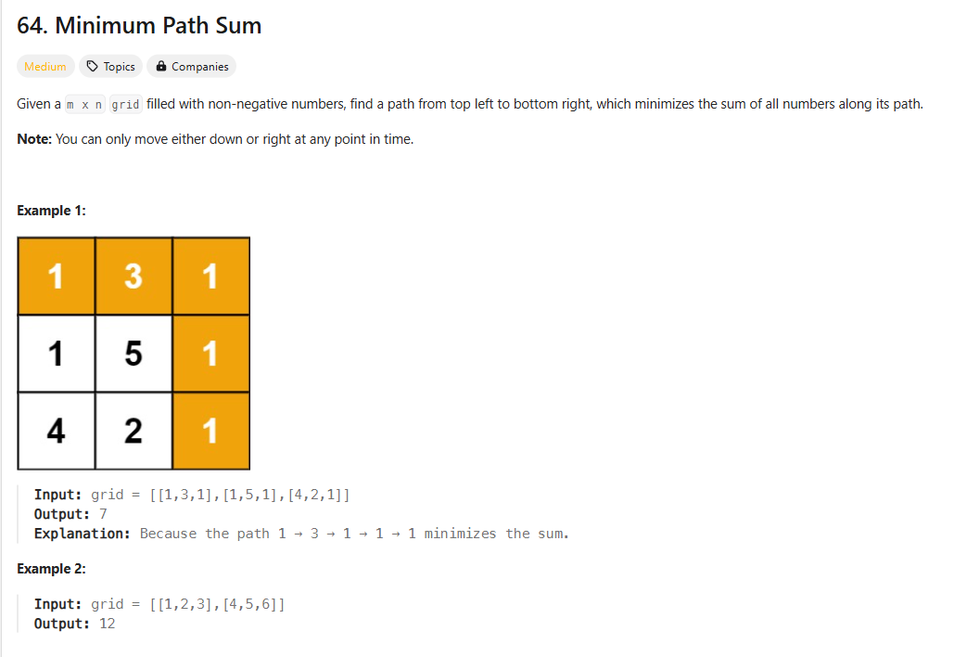
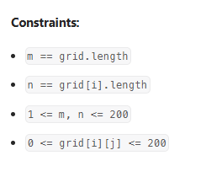
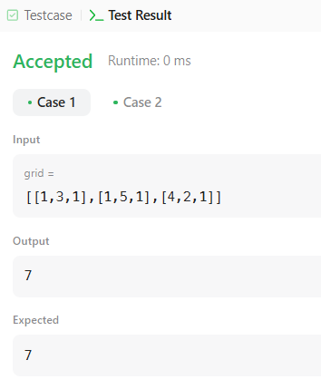
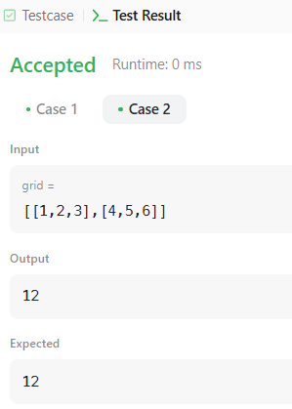

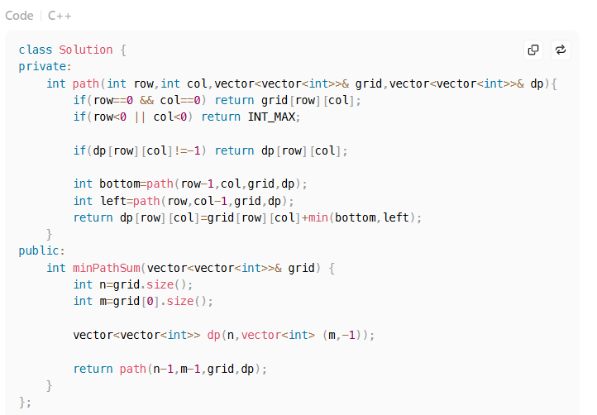

Description + My Approach (C++):
To solve this, I used a recursive approach with dynamic programming. I started by creating a helper function that finds the minimum sum to reach each cell. If I had already calculated the value for a cell, I just used the stored result to save time. At each step, I considered the two possible directions (down and left) and picked the smaller path. I repeated this until I reached the bottom-right corner and returned the minimum sum.

QUESTION # 15

DIFFICULTY: EASY

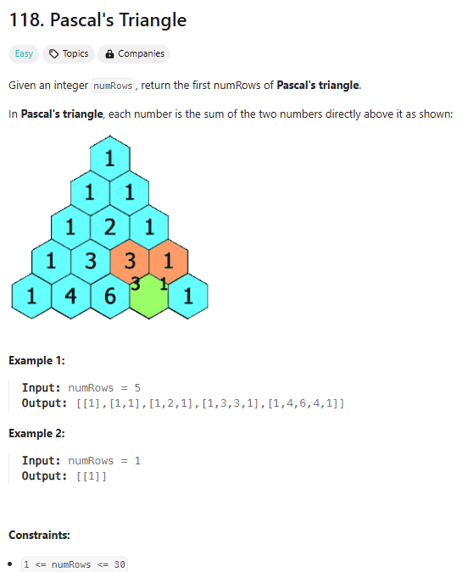
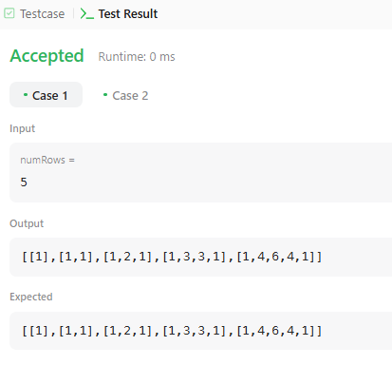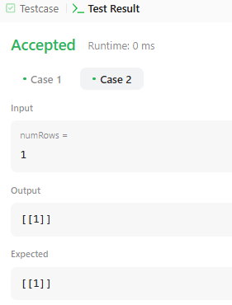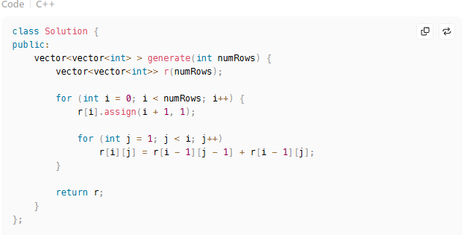

Description + My Approach (C++):
To generate Pascal's Triangle, I created a 2D vector with the required number of rows. For each row, I set the first and last elements to 1. For the elements in between, I added the two numbers from the row above. This way, each row is generated based on the previous one, and I continue this until I reach the desired number of rows. Finally, I return the whole triangle.

QUESTION # 16

DIFFICULTY: EASY

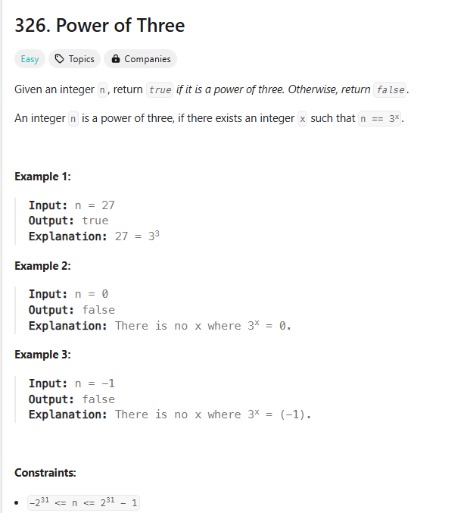
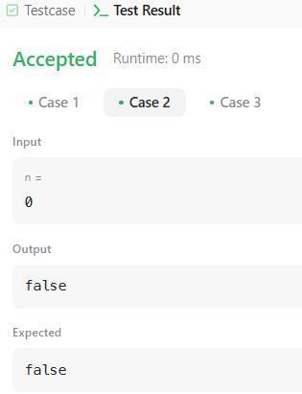
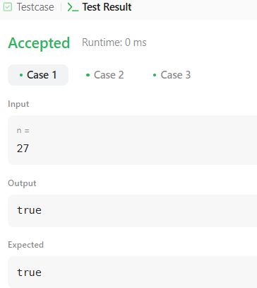
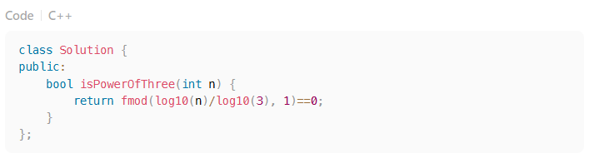

Description + My Approach (C++):
To generate Pascal's Triangle, I created a 2D vector with the required number of rows. For each row, I set the first and last elements to 1. For the elements in between, I added the two numbers from the row above. This way, each row is generated based on the previous one, and I continue this until I reach the desired number of rows. Finally, I return the whole triangle.

QUESTION # 16

DIFFICULTY: EASY

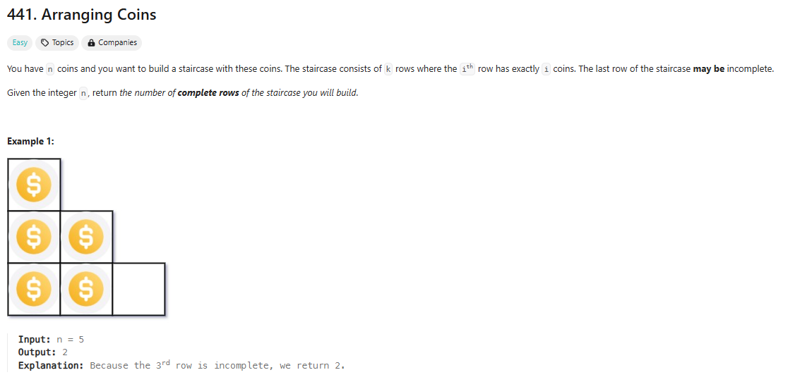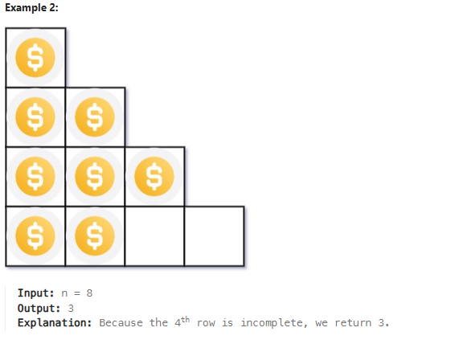
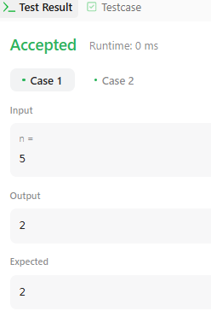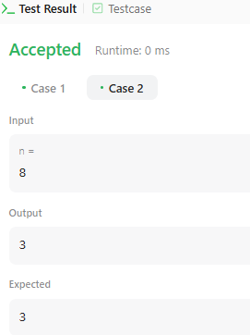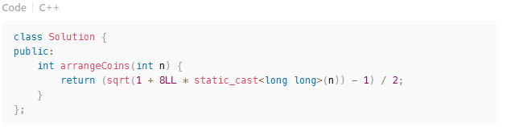

Description + My Approach (C++):
To find how many complete rows of coins can be arranged, I used a mathematical formula derived from the sum of the first k integers. I solved the equation using the quadratic formula, which involves a square root. The formula gives the maximum number of rows, and I return that value by calculating it efficiently in constant time.

QUESTION # 17

DIFFICULTY: EASY

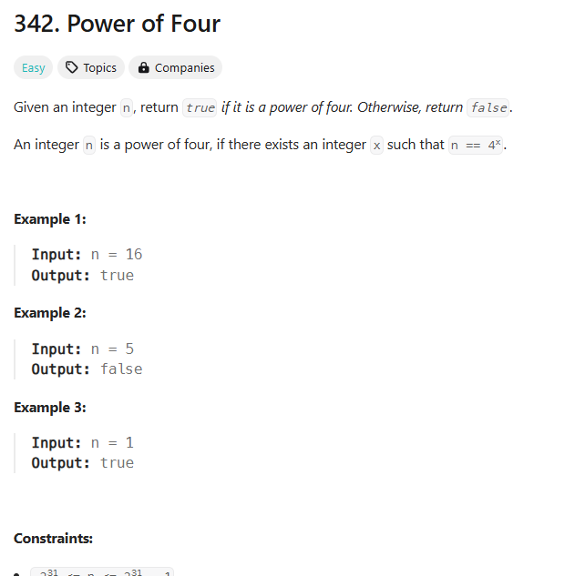
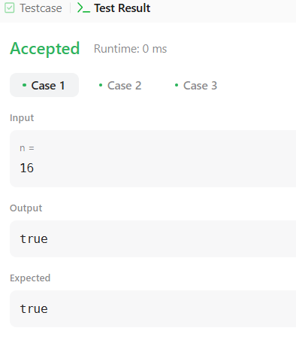
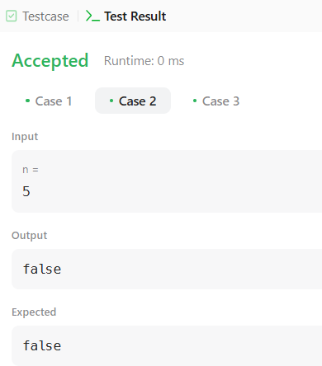

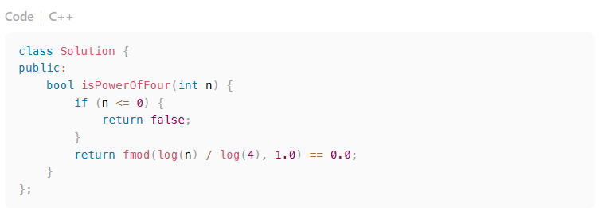

Description + My Approach (C++):
To check if a number is a power of four, I used logarithms. First, I check if the number is positive because negative numbers and zero can't be powers of four. Then, I take the logarithm of the number with base 4 and check if the result is an integer. If it is, the number is a power of four; otherwise, it’s not.

QUESTION # 17

DIFFICULTY: EASY

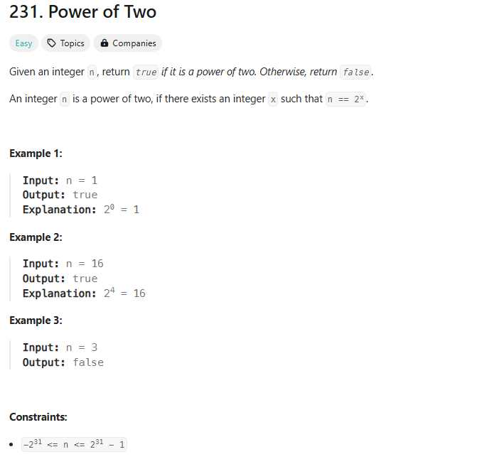
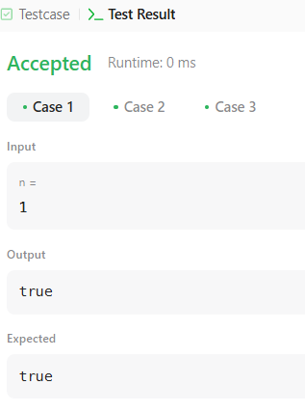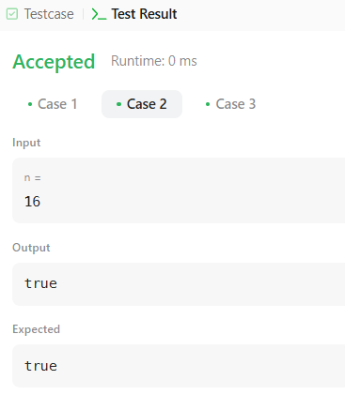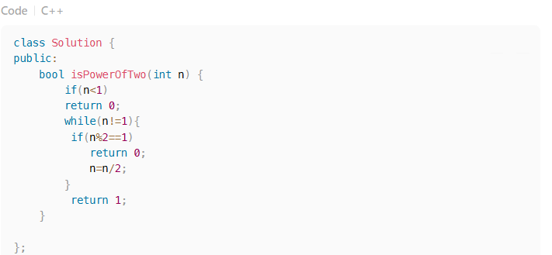

Description + My Approach (C++):
To check if a number is a power of two, I start by ensuring the number is positive because numbers less than 1 cannot be powers of two. Then, I continuously divide the number by 2. If at any point the number is not divisible by 2, I know it's not a power of two. The loop continues until the number becomes 1, which means it’s a valid power of two.

QUESTION # 18

DIFFICULTY: EASY

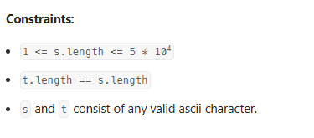
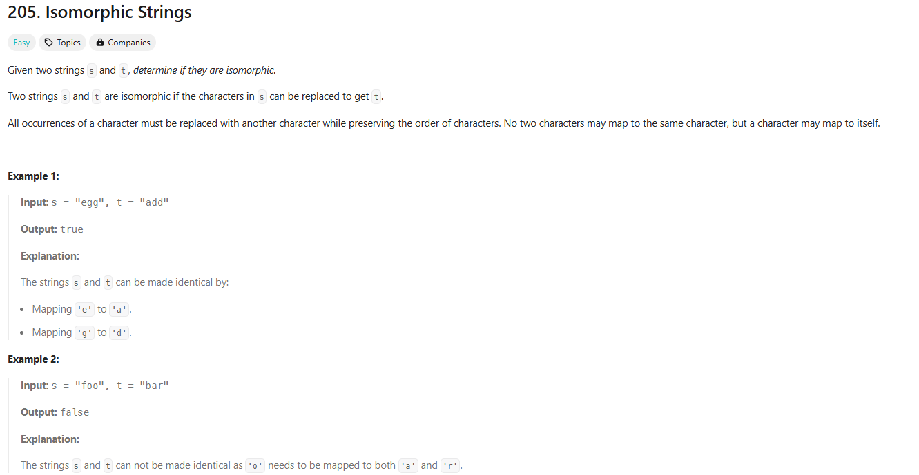
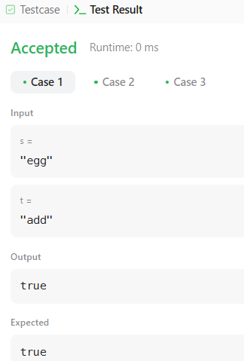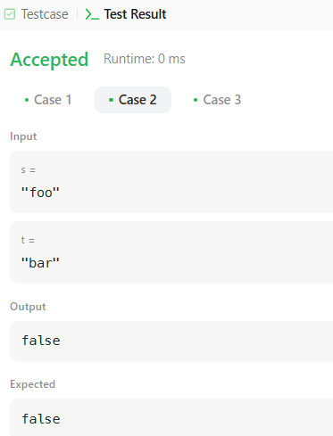


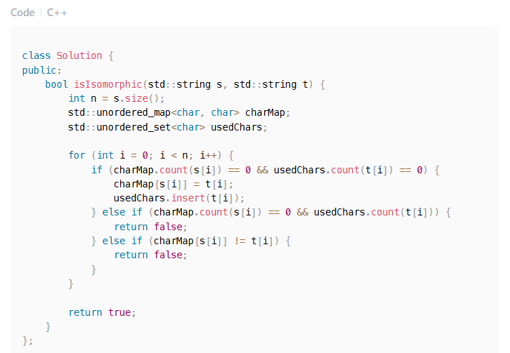

QUESTION # 19

DIFFICULTY: MEDIUM

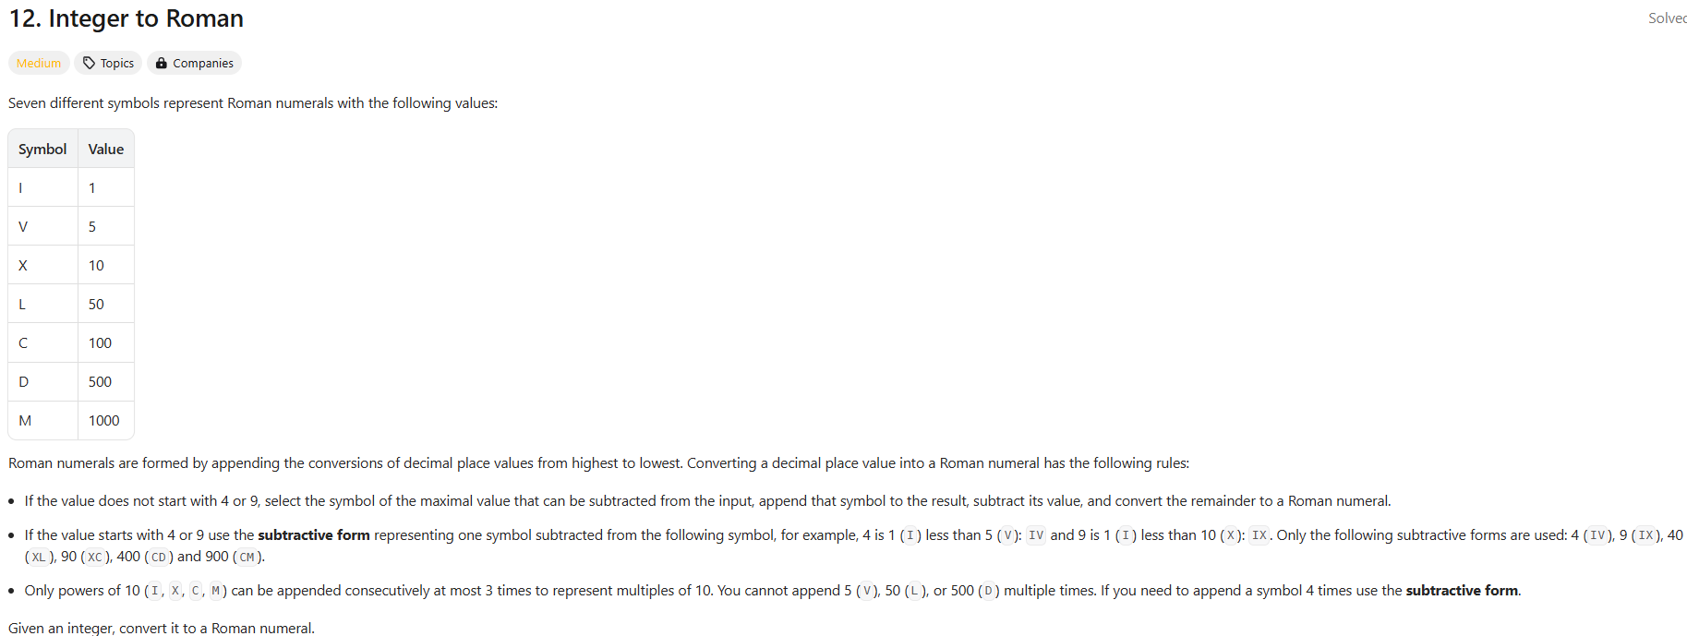
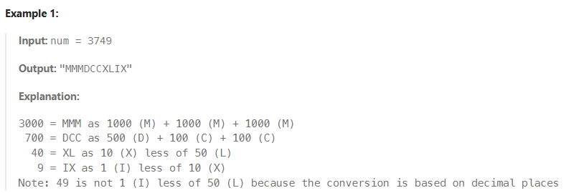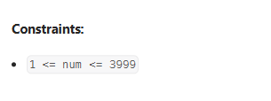

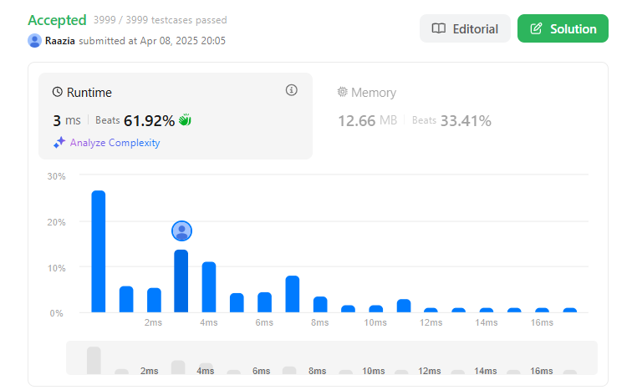

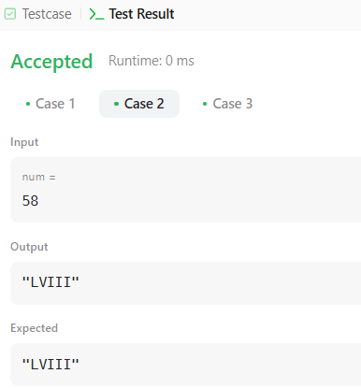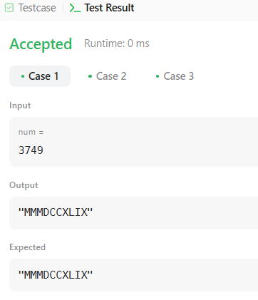
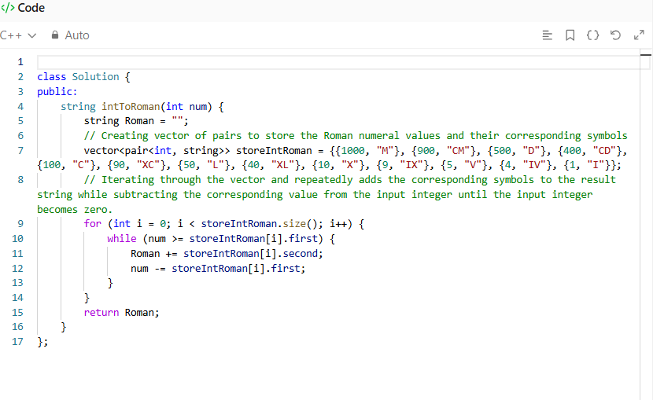

Description + My Approach (C++):
To convert an integer to a Roman numeral, I created a vector of pairs, where each pair consists of an integer value and its corresponding Roman symbol. Starting from the largest value (1000 for "M"), I check if the current number is greater than or equal to the value. If it is, I append the corresponding Roman symbol to the result and subtract the value from the number. I keep doing this until the number becomes zero, ensuring the result string is built correctly.

QUESTION # 20

DIFFICULTY: HARD

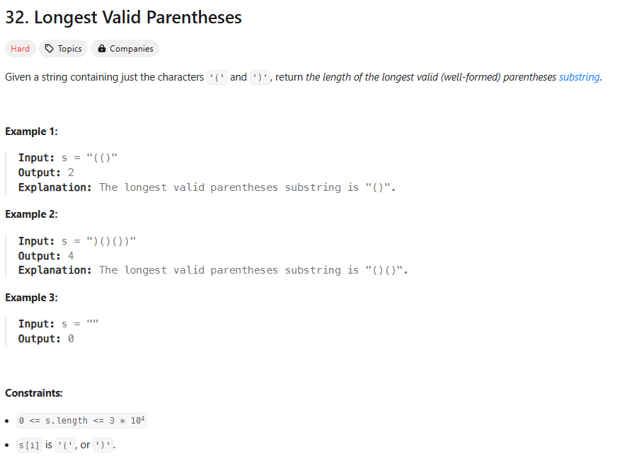
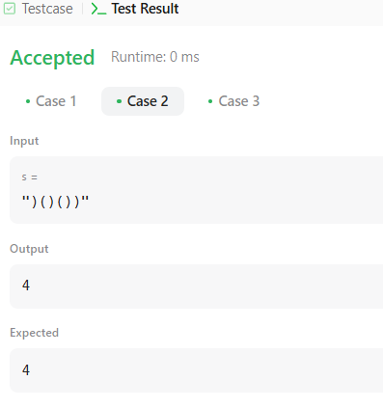
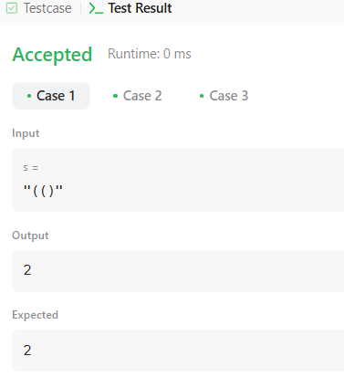
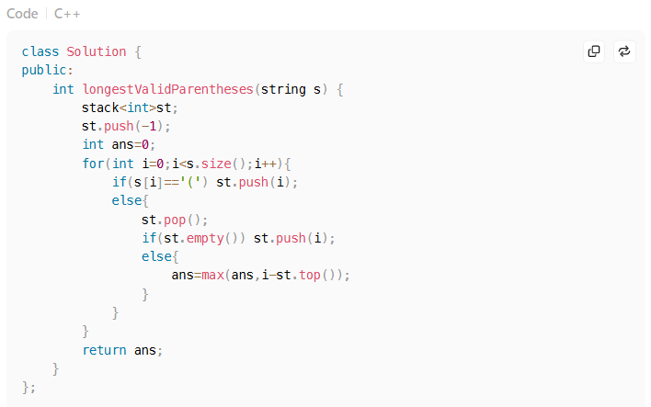

Description + My Approach (C++):
To find the longest valid parentheses substring, I used a stack-based approach:
- I initialized the stack with -1 to handle edge cases like an empty string or starting index.
- I then looped through the string:
  - If I encountered an opening parenthesis (, I pushed its index onto the stack.
  - If I encountered a closing parenthesis ), I popped the top of the stack.
    - If the stack was empty after popping, it means the current closing parenthesis doesn't have a matching opening parenthesis, so I pushed the current index.
    - If the stack wasn't empty, the top of the stack now represents the index of the last unmatched opening parenthesis. I calculated the length of the valid substring as i - st.top() and kept track of the maximum length.
- Finally, I returned the maximum valid length found.

